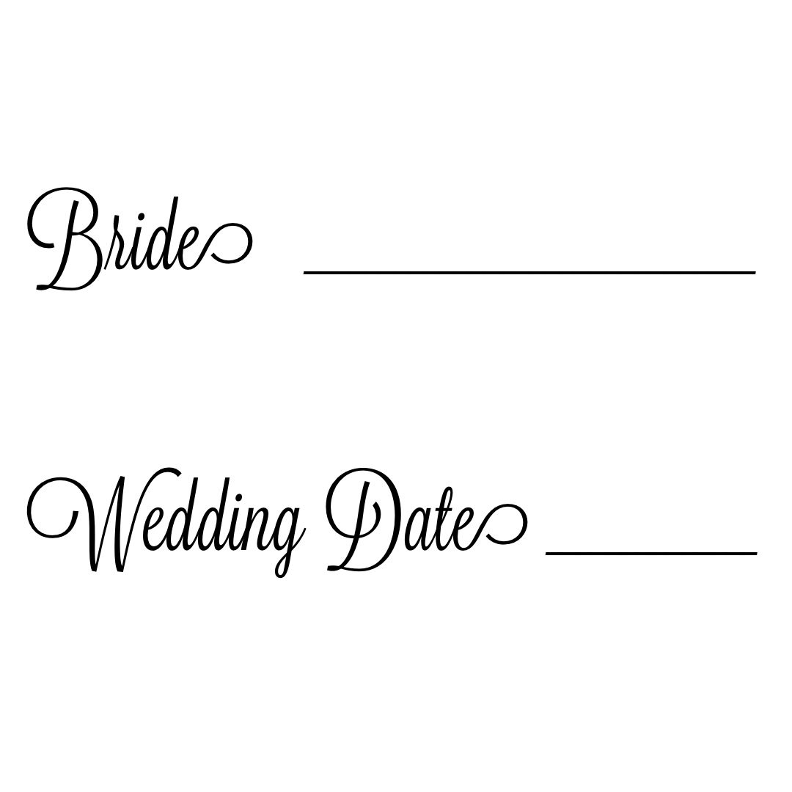

Bride’s pre-trial makeup: Date________…………………………………………………………………… $_________
Bride’s wedding day makeup: Date________..………………………………………….….……….… $_________
Bridesmaid’s makeup ____ x $75 each …….………..………………………………………………….. $_________
Mom’s makeup ____ x $75 each ……………..…………………………………………………….…………. $_________
Touchup kits ____ x $30 each (optional) …………………….………………………………………… $_________
Flower girl’s ____ x $40 each (under 12 free) …………………..……….………………….……. $_________
Assistant fee $100 ………………………………………………………………………………………………………… $_________
On location: Travel fee ______ + Parking dues _______ ……………………………………… $_________
Additional time: ____ hours x $50 hour ………………………………………………………………… $_________
Any additional add-ons: $_________
Deposit to save the date: $100 -PAID date _________ VIA ___________ ………- $_________ -
Remaining balance due on or before the wedding date: …………….………………… $__________

Bride’s Name: __________________________________________ Phone: _______________________
Email: _________________________________________________
Groom’s Name: ________________________________________
Wedding Date: ______________ Start time: __________ Finish time: ____________
**PLEASE Read Terms & Conditions Section #4**
Wedding Venue: _______________________________________
Address: ______________________________________________
_______________________________________________________ Phone: ________________________
Location for makeup if different than Venue: __________________________________________
Address: __________________________________________ Phone: ___________________________
Wedding Coordinator: ______________________________ Phone: ___________________________
Maid/Matron of Honor: _____________________________ Phone: ___________________________
Photographer: ________________________________ IG handle: _____________________________

6-6:45am:
6:45-7:30am:
7:30-8:15am:
8:15-9am:
9-9:45am:
9:45am-10:30am:
10:30-11:15am:
11:15am-12pm:
12-12:45pm:
12:45-1:30pm:
1:30-2:15pm:
2:15-3pm:
3-3:45pm:
3:45-4:30pm:
4:30-5:15pm:
5:15-6pm:

6-6:30am:
6:30-7am:
7-7:30am:
7:30-8am:
8-8:30am:
8:30-9am:
9-9:30am:
9:30-10am:
10-10:30am:
10:30-11am:
11-11:30am:
11:30-12pm:
12-12:30pm:
12:30-1pm:
1-1:30pm:
1:30-2pm:
2-2:30pm:
2:30-3pm:
3-3:30pm:
3:30-4pm:
4-4:30pm:
4:30-5pm:

Please Initial:
- Thank you for trusting us on this most special and happy day. This contract is put in place to ensure communication is clear and agreed upon for both parties so your wedding day goes smoothly and timely. Please review carefully and let us know if you have any questions or concerns so we can better serve you.
______
- Once the trial appointment is booked, a deposit of $100.00 is required to save the wedding date. The deposit is non-refundable.
______
- During the busy wedding season, Saturday weddings will require a MINIMUM of five services or $400.00. (assistant charge not included) If the bride has a large bridal party and/or limited hours, we will need an assistant. The assistant charge is $100.00.
______
- We are committed to making sure that your day goes as smoothly as possible and ask that you are prepared to start and end on the time agreed upon. If you would like for us to stay past the finish time; this must be arranged prior to the wedding date. There is a $50.00/ hour charge for any additional time past our agreed on finish time. This includes extra time IF the bridal party is not prepared to start on time. Extra time charges are to be paid at the time of service or will be billed if needed.
______
- Wedding day! Make sure that all participating bridesmaid’s/mom’s and bride wash their face and apply moisturizer as they would on a normal day. It is recommended that the bridal party wear clothing that is easy to remove without pulling over the styled hair & makeup.
______
- Please discuss payment arrangements and options with the bridal party prior to the wedding day. Payments are to be made at the time of service or prior to, (Things can get hectic at the last minute!) Gratuities are not included and greatly appreciated.
_____
- The cancellation policy includes giving Makeup by Tracie a 3 month courtesy cancellation notice prior to the wedding date. If you adhere to the courtesy cancellation notice, the full payment minus the initial “save your date” deposit will be refunded.
______
- Additional agreements:

I, ___________________________________________________ (print name) have read and fully understand this agreement. By signing below, I hereby agree, consent and will abide by and adhere to all parts of the Bridal Contract (including, but not limited to, its Terms and Conditions, Save the Date, Bridal Party and Itinerary)
X_____________________________________________________________________________ Date __________________

Makeup by Tracie

______________________________________________________________________________ Date __________________
Tracie Campbell

